DOKUZ EYLÜL UNIVERSITY IZMIR

INTERNATIONAL BIOMEDICINE AND GENOME INSTITUTE

“SPECIFICATIONS OF THESES AND THEIR ORTHOGRAPHIC RULES”

Graduate Education Guideline
2018-Izmir

OBJECTIVE
These rules are enforced in order to reach a consensus on the quality and the coordination for the planning, preparation, and writing of Masters and PhD program theses at the Dokuz Eylül University Izmir International Biomedicine and Genome Institute. The master and PhD students that prepare their thesis are obligated to follow these rules.

THESIS SPECIFICATIONS AND CONTENTS
The research thesis is the basis of the graduate education. The study presented in the thesis should be hypothesized, performed, analyzed, and written/drafted/recorded according to the scientific principles and methodology. When writing the thesis, scientific rules must be considered carefully and citations/quotations from journals must be indicted by quotation marks, in addition to being included in the references.

Originality and creativity

At least one of the following criteria should be satisfied in the PhD thesis: presenting novelty to the scientific community, developing new scientific methodologies, or applying a known methodology to a novel scientific field. The research and the writing of the thesis must be completed by the PhD candidate. However, according to the field of research, the independence of the candidate might differ. For instance, in some cases, students may perform their studies as a part of a big research group. Nevertheless, the candidate must show his/her ability to work independently. The publication of the thesis in a national/international journal is necessary to complete the PhD thesis.

Coherence
The sections of the thesis must follow a particular rational and analytic flow in order to achieve a coherent thesis.

Oral/Written Presentation
The orthographic rules of the Izmir Biomedicine and Genome Institute must be followed. The reader must be able to read the thesis without any difficulties. The reader must be able to easily find/ follow the tables, figures, and graphics that are included in the thesis. The text should be succinct, without unnecessary words. The author must avoid any unnecessary repetitions.

Language
The thesis language is English.

Language Style
The language style of the thesis should be simple and clear, and should comply with the scientific text/principles.

Thesis sections
The thesis is divided into three main sections:

Opening (it starts with the index, which is numbered with Roman digits as stated by the page numbering section)
- Outer hard cover (Addendum-1)
- Inner hard cover (Addendum-2)
- Signatures from the jury members
- Indexes
- Table list
- Figure list
- Abbreviations: The abbreviations used in the thesis must be explained along with its explanation the first time the author uses them. Abbreviations cannot be used in the thesis title.
- Acknowledgement / special thanks: This part is dedicated to the people who were significantly involved in the preparation and the thesis work. (Not obligatory)

Main section
The main section of the thesis must include following subsections. (The pages are numbered with Arabic letters/characters starting from abstract as stated in page numbering section)
- English title, abstract, and keywords
- Turkish title, abstract, and keywords
- Introduction and objectives/aims (1-2 pages)
- General information/literature search/ general scope of the research (this should not exceed 1/3rd of the thesis)
- Materials and Methods
- Results
- Discussion
- Conclusions and future directions

Summary

The aim of the summary is to give the reader information about the thesis. The summary should not exceed 250 words. The summary should contain the title, name, faculty, and contact information of the researcher, the aim and hypothesis, method, findings, results, and keywords. Each of the sections should be explained with 1-2 sentences separated by a subheading or as a whole paragraph following the same order. The summary must give information about all aspects of the study included in the thesis. The obtained results must be explained clearly. The author should consider that only the summary section can later be permitted into an index or a reference. The summary should not contain references or a discussion. 3-4 keywords should be added to the end of the summary.

Turkish summary
The Turkish summary must follow the principles and format explained above. It should contain keywords appropriate to the international indexes/publications. The use of the Turkish language must be meticulous and impeccable.

Thesis title
The thesis title must be identical to the one approved by the Izmir International Biomedicine and Genome Institute’s Board.

- Introduction and objectives
This section must contain the description of the problem, its importance, the aim, and the hypothesis of the study. The problem/objective that led to the study must be explained briefly and clearly in the introduction. The aim of the study must be written briefly, simply, and clearly. The dependent and independent variables of the study should be included, if any. Those dependent and independent variables must be included within the thesis title, too. Additionally, the hypothesis and the research questions that are the focus of the thesis must be specified/stated.

- Literature summary / scope of the study
In this section, the published literature related to the subject/topic of the thesis is reviewed in the context of the ongoing research. The literature should not be presented as a list, but should be presented as an analytic and critical review. The problems related to the research topic and suggestions for their solution should be evaluated according to the objective, hypothesis, and the scope of the research outlined in the introduction. It needs to be elaborated/explained/disclosed, which hypotheses will be tested within context of the thesis. A cause and effect relationship between the objectives and the methods should be established based on the literature.
A good literature summary must stimulate the interest of the reader besides being short and to the point. Thus, the research closely related to the topic of the thesis should be included, whilst the unimportant, or off-topic information should be avoided. The information included within this section must be acquired from primary resources and secondary/second-hand resources should not be used. Additionally, information from books should be limited. This section must not exceed 30% of the whole thesis.

- Materials and Methods
This section must be written in such clarity that another researcher can follow it easily.

  - Type of the research:
Descriptive, quasi-experimental, or experimental

  - Location and the time frame of the research:
This must be stated clearly.

  - Research population, sampling and experimental groups:
This section must be included if the study involves human specimen(s). The features of the study population must be stated. The criteria for sample acceptance, selection, and the sampling ratio must be included.

  - Research materials:
The receiving date, resource, and means of acquiring materials used in the research (cell lines, mouse, etc.) must be included.

  - Research variables:
Definable dependent, independent, and control variables must be explained clearly.

  - Data collection tools:
The tools used to collect data (survey, scale, observation, etc.) in the study must be explained/stated simply and clearly. The specifications, types, brands, lot numbers of devices, consumables, and other equipment should be presented in a specific organization.
The pros and cons of the methods and the reason why they are selected must be discussed since a perfect method to collect data in the context of a particular study is not always possible. Methods must be written in such detail that a researcher who is not familiar with the particular method can understand and follow it easily. References must always be included.

  - Research plan and time-line:
The study/experiments of the research from its preparation phase to its conclusion must be presented with their respective dates within a flow chart.

  - Data analysis:
The analysis should aim to resolve the study problem or to test the proposed hypotheses and/or answer questions derived from the research. The reason for the statistical methods used and their adequacy to analyze the data must be discussed within context of the overall objectives. The problems that appeared during the analysis and the approach must be addressed clearly, as well as the means used to overcome those issues. The students must discern/notice unpredictable features/outcomes and must be diligent to show reliability and objectivity.

  - Limitations of the research:
The limitations of the study must be included.

  - Ethical committee approval:
All theses must include the respective Ethic Committee approval. In this section, the Ethic Committee approval date, the document number, the institution permit, and the consent obtained from patients need to be stated. The consent forms must be included in the addendum.

- Results
- The authors must present their results in a clear and logical manner, including the objectives and the analytic approaches.
- The statistical analyses and the representation of the data should comply with the international standards.
- Tables, figures, and other visual aids must properly serve their aim and be numbered accordingly. The same data should not appear in more than one representation format.
- Photographs, if any, must be in high quality and numbered as a ‘figure’.

5. Discussion
How the thesis would contribute to its related field must be evaluated in this section.
- The results obtained by the candidate and the information presented in the literature section must be compared/contrasted in a rational way. Main findings should be discussed in a theoretical and if appropriate in a practice-wise standpoint.
- Additionally, the interaction between different parameters, their contribution to the whole study within the candidate’s findings must be evaluated in great detail.
- In the discussion, the thoughts on the whole research process must be included, to illustrate what the candidate learned through this process.
- If there are reasons why a particular method and/or research plan is used, a section that is discussing the limitations of those approaches as well as alternative methods and their respective outcomes in the context with the results, must be included.

- Conclusions and future directions
- In this section it must be described, how well the aims and objectives that were set at the beginning of the study were achieved and the reasons why the hypotheses were accepted or rejected.
- The points that should be clarified further in the area of the thesis must be stated, if any.
- Future directions of the research must be suggested.

Final chapter/ epilogue
  - References
  - Addenda
  - Acknowledgement (people and/or organizations that had either financial, intellectual, and/or hands-on contributions)

- References
The references included within the thesis should be listed in the order they appear using Arabic numbers or alphabetically. The referenced sources must be read carefully and fully, since only reading the summary can be misleading. The abbreviations within the references must comply with the IndexMedicus. In general;
- (The surname of the author) (first letter of the author’s name), (the surname of the second author) (first letter of the second author’s name), (…)(…). The title of the article (starting with a capital letter then continued with the lowercase letters). Abbreviation of the journal, year; volume: first-last page Example: Thatte ML, Honda T. Venous flaps. Plast Reconstr Surg 1993;91: 744-51
- If there is no international abbreviation of the journal, its complete name must be written.
- If there are more than four (4) authors of an article, the section is finalized by et al. after the fourth author.
- If a quoted passage is included in the thesis, the passage should be written within the quotation marks as (“......”). At the end of the quoted passage, the title, page number and date of the reference source must be included. If the passage is rephrased by the authors, there is no need to include it within the quotation marks and the rules for the general references must be followed.

Other references
Newspaper articles as references are stated as, Newspaper name, publication date (Day, month year): page number, column number. Example: Cumhuriyet, 10 January 2002: 19,2.

The citation of published thesis are described similar to referring to a book, only instead of the publisher the university and the type of the thesis (masters, PhD etc.) should be specified.

An e-article is cited similar to a journal article and the URL of the said article must be included within the reference. Example: Morse SS. Factors in the emergence of infectious diseases. Emerg Infect Dis [serial online]; 1995: [24 screens]. URL: http://www.cdc.gov/ncidod/EID/eid.htm. If the author of the e-article or webpage is undefined, the complete URL of the source must be given as reference.

Electronic monographs must be cited as described in this example: CDI, Clinical Dermatology illustrated [monograph on CD-ROM]. Reeves JRT, Maibach H. CMEA Multimedia Group, producers. 2nd ed. Version 2.0. San Diego: CMEA; 1995.

Congress (memorandum) abstracts are cited as: (The surname of the author) (first letter of the author’s name), (rhe surname of the second author) (first letter of the second author’s name), (…)(…). The title of the abstract (starting with a capital letter then continued with the lowercase letters). Congress/symposium booklet title: Page, Date, Place.
Atabey N, Gao Z-J, Yao ZJ, Breckenridge D, Gao Y, Soon L, Soriano J, Burke TR, Bottaro DP. GRB2-SH2 domain interaction antagonists block hepatocyte growth factor stimulated cell motility, matrix invasion and tubulogenesis. Sixteenth Annual Meeting on Oncogenes Abstract Book: p95, June 22-25, 2000, LaJolla, CA, USA.

Books
If the book has only one author: Author name and surname (the first letters of author’s given name). Book title, edition number, location of the publication, publisher, publication date (as year), Page numbers.
Example: Phillips SJ, Whisnant JP. Hypertension and stroke. In: Laragh JH, Brenner BM, editors. Hypertension: pathophysiology, diagnosis and management. 2nd ed. New York: Raven Press; 1995. p. 465-478.

Book chapter:
Chapter’s authors, title of the chapter, In: Name(s) of the book editors, editors. Book title, edition number, location of publication, publisher, publication date (as year), page numbers.
Ex: Phillips SJ, Whisnant JP. Hypertension and stroke. In: Laragh JH, Brenner BM, editors. Hypertension: pathophysiology, diagnosis and management. 2nd ed. New York: Raven Press; 1995. p. 465-478.

Reviews as Books:
Review’s authors, title of the review, In: Surname(s) and the first letters of the name(s) of the book editors, ed. Book title, edition number, location of publication, publisher, publication date (as year), page numbers.
Ex: Elevitch FR, Hicks GP, Microprocessors and computers in the clinical laboratory, In:Tietz NW, ed. Fundamental of Clinical Chemistry, third edition. Philadelphia: W.B.Saunders, 1987; 254-265.

If the author is an institution:
Institution name. Book title, location of publication, date of publication, page numbers.
Ex: The Cardiac Society of Australia and New Zealand. Clinical Exercise Testing: Safety and performance guidelines. Medl Aust 1996; 164-228.
If the author is undefined: Article title (editorial). Journal or book name, date of publication; page numbers.
Ex: Cancer in South Africa (editorial). S Afr Med 1994; 84-115.
At the end of the thesis the Ethic Committee approval and the published articles related to the thesis must be included.

Webpages as references:
The full title of the webpage and the date of the citation must be stated.

- Addenda
(Ethic Committee report, CV in ARBIS format, publication list, manuscripts related to the PhD thesis, and the acceptance letters from the journal)

- STRUCTURAL SPECIFICATIONS FOR THE THESIS

  - Paper type
The thesis must be printed on high-grade, 90-100 grams A4 (210x297mm) white paper. After the binding, the dimensions of the thesis must be 205x290mm.

  - Cover
The front and back covers must be prepared from glossy white paper. The cover page must be prepared according to the example in Addendum-1. The binder of the thesis can be covered by either black or white tape/plaster. The font sizes and types of the cover page are stated in Addendum-1.

  - Inside cover
The inside cover is similar to the front cover, plus the code of the thesis, the names of the supervisor, and organizations that supported the research. The inside cover must be printed on white high-grade, 90 grams A4 paper. The inside cover must be prepared according to the example in Addendum-1. The font sizes and types of the cover page are stated in Addendum-1.
  - Orthographic specifications
Page organization
Page margins must be 3 cm each for the header and footer and 2 cm each for the right and left sides. In order to keep the organization intact, all lines must be at the same block. The text within the thesis must be written in size 12, with either Ariel, Tahoma, Times New Roman or Courier font without italic and with 1.5 spacing. The headings that are end up at the bottom of a page must be transferred to the next page if they are not followed by at least two lines of text. The paragraphs must have an additional 1 cm indent. The numbers lower than 10 must be written by letters, the numbers higher than 10 must be represented numerically. The numbers at the beginning of a sentence must be represented by letters. The main headings must be written bold and underlined, the subheadings written in bold, and subsections within that subheadings written in italic. The main headings must be written all in uppercase, whereas the subheadings, each word must be capitalized. Thesis should be printed with a laser printer.

Page numbers
In the figure and table indexes, numbers must be typed as small roman numericals, like i, ii, iii, iv, v, etc. For the page numbers, Arabic digits, e.g. 1, 2, 3, etc. must be used, starting from the abstract. The numbers must be located at the bottom of the page, 3 cm from the side margin and 2 cm from the bottom margin, aligned with the right side of the text, and typed using the same font size and type as the main text.

Tables and figures
Tables and figures are used to clarify points that are harder to be explained by text. The authors should not use tables or figures unnecessarily. All the components of the figures (graphs, diagrams, pictures, etc.), including the lines, symbols, numbers, and text must be printed by a printer, typewriter, rapid pen or lettersets. All symbols, numbers, and texts must be clear and legible. If there is more than one section shown in the figure, the elements must be identified by capital letters, e.g. A, B, C, and each element must be explained separately. The photos of patient and/or human subjects must be presented without giving the true identity of those subjects, e.g. by covering the eyes with black boxes. In special cases, the photos can be included without any coverage, if a consent from the subject was obtained and is included with a photo. Non-digital photos are printed at least 9x13 size, either in full color or black and white. These photos must be printed on semi-gloss paper. At least 6 of the thesis must include those original photos. To avoid bulging of the thesis, the printing material for these photos should be thin. Non-digital pictures can be scanned and printed directly to the page if the scanning process is done in sufficiently high resolution.

All figures and tables must be placed on the same or the next page where they are mentioned in the text, according to the structural rules provided above. Tables and figures are numbered by Arabic numbers (e.g. Table 1, Figure 2). The information regarding the respective figures and tables must be given after the number. If any of the information is derived from another source, then the reference must be included.

The tables information must be written above the table and there must be a 6 font space between the last line of the information and the table. The information about the figures must be typed below the figure and there must be a 6 font space between the last line of the explanation and the figure.
The titles of the tables and figures must be idential to the titles listed in the index. Every figure and table must be cited in the text.

Abbreviations
The abbreviations must comply with the scientific terminology. They should be used only if necessary and they must be explained once, within parentheses where they are used for the first time. All measurements must be given in the metric system and their abbreviations must be compatible with the international unit system (e.g. L, g, etc.). The measurements units, except the frequently used ones (cm, mL, etc.), must be defined the first time they are mentioned in the text. Non-standard units and abbreviation should not be used. A full stop must be included at the end of the abbreviations that are not associated with the terminology (e.g. Ex., etc.). If the abbreviation consists of initials of multiple words, then a full stop should not be included (e.g. TUBITAK). All the abbreviations must be abbreviated according to their English terms, however, frequently used ones can be cited as it is. All abbreviations and their explanation must be included within the index section.

Footnotes
Footnotes can be included in the footer to its associated page, underneath a straight line, font size 10.

Thesis addenda
The addenda to a thesis are the information/explanations that are considered as distractive, too long for a footnote, or that complicate the reading process for the reader. Those addenda are cited as (see also Addendum-1). Each addendum must start on a new page, be enumerated with a different number (addendum 1, Addendum 2, Addendum 3, etc.), and must be listed sequentially and complete within the index. Floppy discs, CDs, video cassettes, etc. must be included separately from the thesis and their structure must be identical with the thesis cover page.

- THESIS SUBMISSION
Seven copies of the thesis must be printed for deliver to the jury members. Furthermore, an unbound copy of the thesis should be submitted to the institute a month before the thesis defense. For PhD theses, an acceptance letter from a national/international journal along with an article manuscript regarding to a part or whole of the research study must be submitted with the thesis to the institute. After the thesis submission, the date of the thesis defense and the jury members will be determined and the thesis will be deliver to the jury members by the institute. For the thesis submission, the Turkish and English abstracts, which were prepared according to above rules will be delivered separately.
The examination official report and the thesis evaluation forms for the jury members, which are obtained from the institute before the thesis defense, must be submitted to the institute within three (3) days after the defense.
For the graduation, all the required documents must be submitted to the institute within a month after the thesis defense.
For control and for access by other researchers, all theses regarding masters, PhD, medical specialization, and qualification in arts degrees, are collected since 1987 within the YÖK’s Documentation Center and uploaded into a database.
Additional to the information included in the YOK’s database, a ‘Thesis Information Form’ must be filled to present/include those graduate theses established in our country in international databases.
If graduate student’s thesis is supported by the D.E.Ü. Scientific Research Projects (BAP) department, student must prepare five (5) copies of the report according to the BAP regulations and submit it to the institute for them to deliver to DEU rectorate then BAP.
According to the Graduate Education regulations, graduation decision is made by the institute board, once the latest version of the thesis along with the appropriate documents must be submitted to the institute within a month of defense at the latest.

- THESIS EVALUATION FORM (FOR THE JURY MEMBERS)
The thesis evaluation form which will be filled by the jury members is included at the addendum-3 in order to help the students.

Addendum 1 (sample thesis format) - Page 1

T.C.
DOKUZ EYLÜL ÜNIVERSITESI IZMIR INTERNATIONAL BIOMEDICINE AND GENOME INSTITUTE (font size 14)

THE TITLE OF THE PhD/MASTER THESIS
(font sIZE 20-BOLD)

NAME-SURNAME OF THE CANDIDATE (font sIZE 18)

PhD-MASTER EDUCATION PROGRAM NAME
MASTER/PhD THESIS (font SIZE 18)

IZMIR-DATE (font SIZE 16)
The font options of this page are Arial, Tahoma, or Times New Roman)

THESIS CODE: DEU.HSI.MSc/PhD-Student number

Page 2

T.C.
DOKUZ EYLÜL ÜNIVERSITESI
IZMIR INTERNATIONAL BIOMEDICINE AND GENOME INSTITUTE (font size 14)

THE TITLE OF THE PhD/MASTER THESIS
(font size 20-BOLD)

PhD-MASTER EDUCATION PROGRAM NAME
MASTER/PhD THESIS (font size 18)

NAME-SURNAME OF THE CANDIDATE (font SIZE 16)

Supervisor: Title, Name, Surname (font size 14)

If the thesis is supported by a grant, the supporting institution and the project number (Size 12)
(This research is supported by DEU Scientific Research Projects Department, 99.3456.23.)

THESIS CODE: DEU.HSI.MSc/PhD-Student number

Page-3

Dokuz Eylül University Izmir International Biomedicine and Genome Institute …………………Department,
………………PhD /Master program student ……………………. successfully completed the PhD/Master thesis entitled ‘thesis title’ on …………….(date)

HEAD OF THE COMMITTEE

MEMBER MEMBER

MEMBER MEMBER

Page-4

INDEXES
Indexes i
Table index. iv
Figure index. iv
Abbreviations v
Summary (Turkish) 1
Summary (English) 2

1. Objective and Aims………………………………………………………………………………………….
1.1. Description and importance of the problem...............................................................................
1.2. Research aims/objectives.........................................................................................................
1.3. Research hypothesis……………………………………………………………………………………………………………..

2. LITERATURE SUMMARY …………………………………………………………………………………...

3. MATERIALS AND METHODS ………………………………………………………………………………
3.1. Type of research …………………………………………………………………………………………………………………
3.2. The location and date of the research:………………………………………………………………………………….
3.3. Research population, sampling and experimental Groups (human specimens)…………………………….
3.4. Materials …………………………………………………………………………………………………………………………….
3.5. Research variables.......……………………………………………………………………………………………….
3.6. Methods......................…………………………………………………………………………………………………………
3.7. Research plan………………………………………………………………………………………………………………………
  - Evaluation of the data………………………………………………………………………………………………………………….
  - Limitation of the research……………………………………………………………………………………………………..
  - Ethic Committee approval…………………………………………………………………………………………………..

4. RESULTS………………………………………………………………………………………………………….
5. DISCUSSION……………………………………………………………………………………………………
6. CONCLUSION AND FUTURE DIRECTIONS…………………………………………………………
7. REFERENCES…………………………………………………………………………………………………....
8. ADDENDA………………………………………………………………………………………………………..

Page-5

TABLE INDEXES

Page No

Table 1...........................................................................................................
Table 2............................................................................................................
Table 3...........................................................................................................
Table 4...........................................................................................................

Page-6
FIGURE INDEX
Page No FIGURE 1............................................................................................................
FIGURE 2............................................................................................................

Page-7

ABBREVIATIONS

The abbreviations used in the thesis must be explained along with its explanation the first time the author uses them. Abbreviations cannot be used in the thesis title.

BMI…………………………. Body Mass Index WHO……………………….. World Health Organization UN…………………………. United Nations
PHC……………………….. Parental Health Center

Page-8

Acknowledgement

This part is dedicated to the people who are involved in the preparation, and thesis study in great deal. (Not obligatory)

Page-9
Thesis title in English

Ex: EFFECTS OF NUTRITION EDUCATION PROGRAM (independent variant) ON PRESCHOOL CHILDREN’S NUTRITION KNOWLEDGE, BEHAVIORS AND ANTHROPOMETRIC MEASUREMENTS (dependent variant)

Ör: OKUL ÖNCESİ ÇOCUKLARA VERİLEN BESLENME EĞİTİMİNİN (Bağımsız Değişken) ÇOCUKLARIN BESLENME BİLGİSİNE, DAVRANIŞLARINA VE ANTROPOMETRİK ÖLÇÜMLERİNE (Bağımlı Değişken) ETKİSİ

Researcher’s name, faculty, contact information
SUMMARY
The aim of the summary is to give the reader information about the thesis. The summary should not exceed 250 words. The summary should contain the title, name, faculty, and contact information of the researcher, the aim and hypothesis, method, findings, results, and keywords. Each of the sections should be explained with 1-2 sentences separated by a subheading or as a whole paragraph following the same order. The summary must give information about all aspects of the study included in the thesis. The obtained results must be explained clearly. The author should consider that only the summary section can later be permitted into an index or a reference. The summary should not contain references or a discussion. 3-4 keywords should be added to the end of the summary.

Aims/Objectives: Methods:
Results:
Conclusion:
Keywords:

Page-11

- Introduction and Objectives
This section must contain the description of the problem, its importance, the aim, and the hypothesis of the study. The problem/objective that led to the study must be explained briefly and clearly in the introduction. The aim of the study must be written briefly, simply, and clearly. The dependent and independent variables of the study should be included, if any. Those dependent and independent variables must be included within the thesis title, too. Additionally, the hypothesis and the research questions that are the focus of the thesis must be specified/stated.
Page-12

- Literature Summary/Scope of the Study

In this section, the published literature related to the subject/topic of the thesis is reviewed in the context of the ongoing research. The literature should not be presented as a list, but should be presented as an analytic and critical review. The problems related to the research topic and suggestions for their solution should be evaluated according to the objective, hypothesis, and the scope of the research outlined in the introduction. It needs to be elaborated/explained/disclosed, which hypotheses will be tested within context of the thesis. A cause and effect relationship between the objectives and the methods should be established based on the literature.
A good literature summary must stimulate the interest of the reader besides being short and to the point. Thus, the research closely related to the topic of the thesis should be included, whilst the unimportant, or off-topic information should be avoided. The information included within this section must be acquired from primary resources and secondary/second-hand resources should not be used. Additionally, information from books should be limited. This section must not exceed 30% of the whole thesis.

Page-13

3. Materials and Methods
This section must be written in such clarity that another researcher can follow it easily.

3.1 Type of the research:
Descriptive, quasi-experimental, or experimental

Page-14

3.2 Location and the time frame of the research:
This must be stated clearly.

Page-15

3.3 Research population, sampling and experimental groups:
This section must be included if the study involves human specimen(s). The features of the study population must be stated. The criteria for sample acceptance, selection, and the sampling ratio must be included.

3.4 Research materials:
The receiving date, resource, and means of acquiring materials used in the research (cell lines, mouse, etc.) must be included.

Page-16

3.5 Research variables:
Definable dependent, independent, and control variables must be explained clearly.

Page-17

3.6 Data collection tools:
The tools used to collect data (survey, scale, observation etc...) in the study must be explained/stated simply and clearly.

Ex: Personal information Form

The tools used to collect data (survey, scale, observation, etc.) in the study must be explained/stated simply and clearly. The specifications, types, brands, lot numbers of devices, consumables, and other equipment should be presented in a specific organization.
The pros and cons of the methods and the reason why they are selected must be discussed since a perfect method to collect data in the context of a particular study is not always possible. Methods must be written in such detail that a researcher who is not familiar with the particular method can understand and follow it easily. References must always be included.

Page-18

3.7 Research plan and time-line:
The study/experiments of the research from its preparation phase to its conclusion must be presented with their respective dates within a flow chart.
Ex:
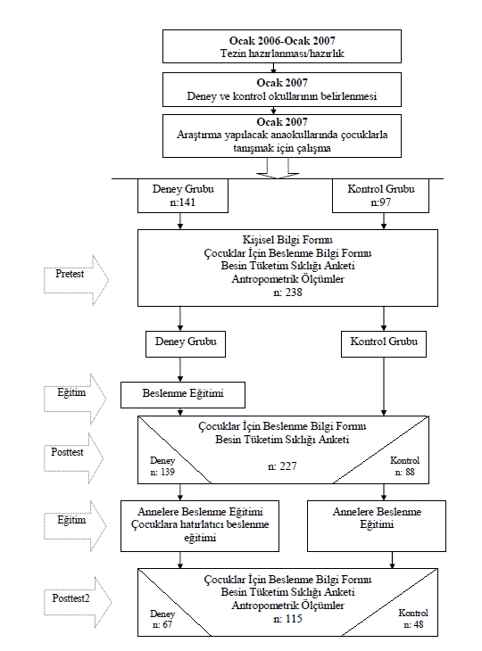

Page-19

3.8 Data analysis:
The analysis should aim to resolve the study problem or to test the proposed hypotheses and/or answer questions derived from the research. The reason for the statistical methods used and their adequacy to analyze the data must be discussed within context of the overall objectives. The problems that appeared during the analysis and the approach must be addressed clearly, as well as the means used to overcome those issues. The students must discern/notice unpredictable features/outcomes and must be diligent to show reliability and objectivity.

Page-21

3.9 Limitations of the research:
The limitations of the study must be included.

Page-22

3.10 Ethical committee approval:
All theses must include the respective Ethic Committee approval. In this section, the Ethic Committee approval date, the document number, the institution permit, and the consent obtained from patients need to be stated. The consent forms must be included in the addendum.

Page-23

4. Results
- The authors must present their results in a clear and logical manner, including the objectives and the analytic approaches.
- The statistical analyses and the representation of the data should comply with the international standards.
- Tables, figures, and other visual aids must properly serve their aim and be numbered accordingly. The same data should not appear in more than one representation format.
- Photographs, if any, must be in high quality and numbered as a ‘figure’.

Page-24

5. Discussion
How the thesis would contribute to its related field must be evaluated in this section.
- The results obtained by the candidate and the information presented in the literature section must be compared/contrasted in a rational way. Main findings should be discussed in a theoretical and if appropriate in a practice-wise standpoint.
- Additionally, the interaction between different parameters, their contribution to the whole study within the candidate’s findings must be evaluated in great detail.
- In the discussion, the thoughts on the whole research process must be included, to illustrate what the candidate learned through this process.
- If there are reasons why a particular method and/or research plan is used, a section that is discussing the limitations of those approaches as well as alternative methods and their respective outcomes in the context with the results, must be included.

Page-25

6. Conclusions and future directions
- In this section it must be described, how well the aims and objectives that were set at the beginning of the study were achieved and the reasons why the hypotheses were accepted or rejected.
- The points that should be clarified further in the area of the thesis must be stated, if any.
- Future directions of the research must be suggested.

Page-26

- 7. References
The references included within the thesis should be listed in the order they appear using Arabic numbers or alphabetically. The referenced sources must be read carefully and fully, since only reading the summary can be misleading. The abbreviations within the references must comply with the IndexMedicus. In general;
- (The surname of the author) (first letter of the author’s name), (the surname of the second author) (first letter of the second author’s name), (…)(…). The title of the article (starting with a capital letter then continued with the lowercase letters). Abbreviation of the journal, year; volume: first-last page Example: Thatte ML, Honda T. Venous flaps. Plast Reconstr Surg 1993;91: 744-51
- If there is no international abbreviation of the journal, its complete name must be written.
- If there are more than four (4) authors of an article, the section is finalized by et al. after the fourth author.
- If a quoted passage is included in the thesis, the passage should be written within the quotation marks as (“......”). At the end of the quoted passage, the title, page number and date of the reference source must be included. If the passage is rephrased by the authors, there is no need to include it within the quotation marks and the rules for the general references must be followed.

Other references
Newspaper articles as references are stated as, Newspaper name, publication date (Day, month year): page number, column number. Example: Cumhuriyet, 10 January 2002: 19,2.

The citation of published thesis are described similar to referring to a book, only instead of the publisher the university and the type of the thesis (masters, PhD etc.) should be specified.

An e-article is cited similar to a journal article and the URL of the said article must be included within the reference. Example: Morse SS. Factors in the emergence of infectious diseases. Emerg Infect Dis [serial online]; 1995: [24 screens]. URL: http://www.cdc.gov/ncidod/EID/eid.htm. If the author of the e-article or webpage is undefined, the complete URL of the source must be given as reference.

Electronic monographs must be cited as described in this example: CDI, Clinical Dermatology illustrated [monograph on CD-ROM]. Reeves JRT, Maibach H. CMEA Multimedia Group, producers. 2nd ed. Version 2.0. San Diego: CMEA; 1995.

Congress (memorandum) abstracts are cited as: (The surname of the author) (first letter of the author’s name), (rhe surname of the second author) (first letter of the second author’s name), (…)(…). The title of the abstract (starting with a capital letter then continued with the lowercase letters). Congress/symposium booklet title: Page, Date, Place.
Atabey N, Gao Z-J, Yao ZJ, Breckenridge D, Gao Y, Soon L, Soriano J, Burke TR, Bottaro DP. GRB2-SH2 domain interaction antagonists block hepatocyte growth factor stimulated cell motility, matrix invasion and tubulogenesis. Sixteenth Annual Meeting on Oncogenes Abstract Book: p95, June 22-25, 2000, LaJolla, CA, USA.

Books
If the book has only one author: Author name and surname (the first letters of author’s given name). Book title, edition number, location of the publication, publisher, publication date (as year), Page numbers.
Example: Phillips SJ, Whisnant JP. Hypertension and stroke. In: Laragh JH, Brenner BM, editors. Hypertension: pathophysiology, diagnosis and management. 2nd ed. New York: Raven Press; 1995. p. 465-478.

Book chapter:
Chapter’s authors, title of the chapter, In: Name(s) of the book editors, editors. Book title, edition number, location of publication, publisher, publication date (as year), page numbers.
Ex: Phillips SJ, Whisnant JP. Hypertension and stroke. In: Laragh JH, Brenner BM, editors. Hypertension: pathophysiology, diagnosis and management. 2nd ed. New York: Raven Press; 1995. p. 465-478.

Reviews as Books:
Review’s authors, title of the review, In: Surname(s) and the first letters of the name(s) of the book editors, ed. Book title, edition number, location of publication, publisher, publication date (as year), page numbers.
Ex: Elevitch FR, Hicks GP, Microprocessors and computers in the clinical laboratory, In:Tietz NW, ed. Fundamental of Clinical Chemistry, third edition. Philadelphia: W.B.Saunders, 1987; 254-265.

If the author is an institution:
Institution name. Book title, location of publication, date of publication, page numbers.
Ex: The Cardiac Society of Australia and New Zealand. Clinical Exercise Testing: Safety and performance guidelines. Medl Aust 1996; 164-228.
If the author is undefined: Article title (editorial). Journal or book name, date of publication; page numbers.
Ex: Cancer in South Africa (editorial). S Afr Med 1994; 84-115.
At the end of the thesis the Ethic Committee approval and the published articles related to the thesis must be included.

Webpages as references:
The full title of the webpage and the date of the citation must be stated.

Page-27

8. Addenda
Ethical committee report, CV in ARBIS format and publication list, manuscript(s) related to PhD thesis and the acceptance letter from the journal
Ex: Ethical committee report

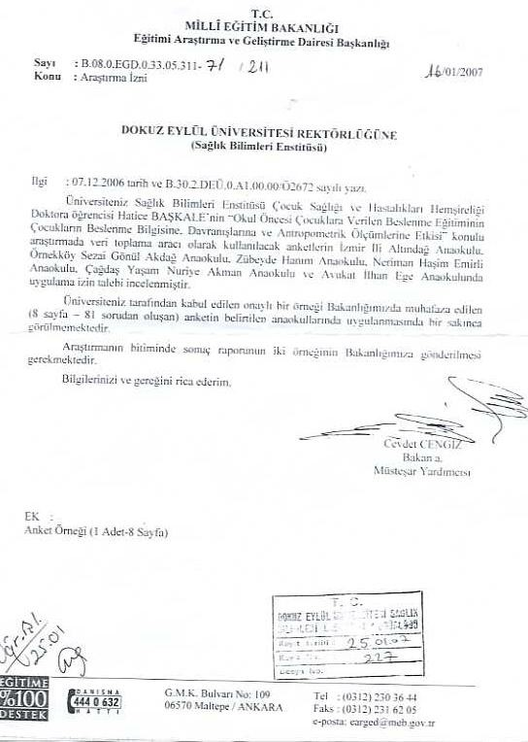

Page-28

Ex: CV in ARBIS format

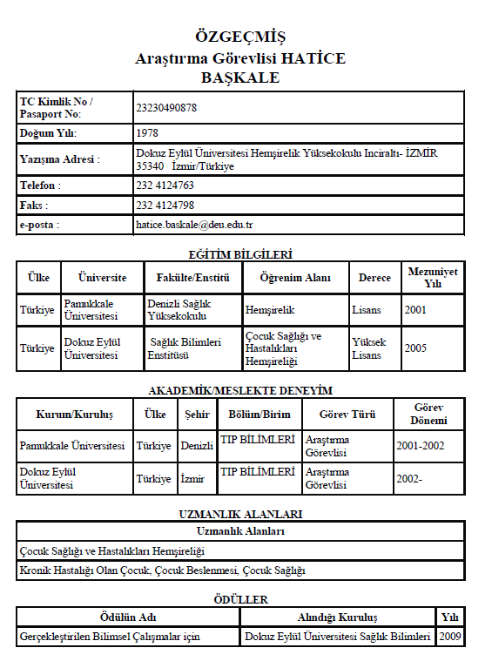

Page-29

Ex: Publications from the thesis

- Author names Piaget’nin Bilişsel Gelişim Kuramıyla İlgili Bir Gözden Geçirme, Dokuz Eylül Üniversitesi Hemşirelik Yüksekokulu Elektronik Dergisi, 2008, 1 (2): 133-147

- Author names Piaget’s Cognitive Development Theory And Nutrition Education Experiences, Asia Pacific Education Review Journal (Under evaluation)

Page-30

STRUCTURAL SPECIFICATIONS FOR THE THESIS

Page Organization

1 cm
3 cm
3 cm each from header and footer, 2 cm from right margins
cm
2 cm
3 cm

3

• Numbers smaller than 10 must be written with letters, the numbers higher than 10 must be represented numerically
•Size 12 font
•Times New Roman Arial, Tahoma
•1.5cm spacing
• Main sections are in bold underlined
• Subsections are in bold
• Sections within subsections are in italic.

• The numbers at the beginning of a sentence must be represented with letters.

Addendum-2

IBG-Institute THESIS EVALUATION FORM (For jury members)
STUDENT INFORMATION
Name
: Department :
Surname
: Program
:
Student #:
Thesis code: :

Master / PhD
Supervisor
:
Secondary Supervisor (If any) :

THESIS TITLE:

PRESENTATION | Does the thesis title describe the topic of the research clearly and adequately? Yes Needs correction
Can the thesis be read and understood easily and clearly?
Yes Needs partial correction Needs rewriting
Are the table, figures, and graphs prepared according to the thesis guide?
Yes Needs correction
 | References Correct Incorrect Explanation:
COHERENCE | Are the thesis sections connected to each other in a logical and analytical manner?  Yes No  Explanation :
ORIGINALITY AND CREATIVITY | In your opinion, did the candidate gain the ability to perform scientific research, seek and find a specific information, analyze and evaluate the data?  Yes No  The PhD thesis must satisfy at least one of these conditions:  The thesis :  Brings novelty  Develops novel methods  Applies a known method to a novel area of research
INTRODUCTION | Are the problem relevant to the research indicated clearly: Yes No  Is the hypothesis related to the research questions stated clearly?:  Yes No
LITERATURE SUMMARY | Did candidate comprehend and learn whilst writing  the literature summary? Yes No  Please write down your opinions in compliance with the Thesis Evaluation Criteria.

MATERIALS and METHODS | Please write down your opinions in compliance with the Thesis Evaluation Critera:
RESULTS | Please write down your opinions in compliance with the Thesis Evaluation Critera:
DISCUSSION | Please write down your opinions in compliance with the Thesis Evaluation Critera:
CONCLUSION and FUTURE DIRECTIONS | Are the results clearly defined and correlated with the hypothesis and the research questions?
REFERENCES | Are the references cited correctly and adequately? Are the latest references included?
ADDENDA | Are any of them missing? For PhD thesis an acceptance letter and manuscript; an ethic approval for all of the thesis; CV in Arbis format and a list of publications
OTHER | Please include any important points regarding to the thesis:
JURY EVALUTION RESULT | In compliance with the Dokuz Eylül University Graduate Education and Examination regulations, this thesis (evaluated by myself) is:  Accepted.  It should be given extra time for corrections. Rejected.
JURY MEMBER’S

Name-Surname : Department : University/Institute : Date: Signature:

